INVITATION TO QUOTE FOR

Westcott: Disruptive Innovation for Space Centre (DISC)
Full Business Case

Issued by: Buckinghamshire Local Enterprise Partnership

Date: 25th October 2022

Contact: Richard Harrington

Table of Contents

INSTRUCTIONS 3
1 Introduction 3
2 Submission of Quotes 3
3 Form of Quote 3
4 Evaluation of Submissions 4
5 Financial Arrangements 4
6 Timetable 5
7 Contract Documents 5
Appendix 1 – Outline Brief 6
Appendix 2 –Form of Quote……………………………….………………………..9
Appendix 3 – DISC Outline Business Case (June 2021)………………………12
Appendix 4 - Key Stakeholders……………………………………………… …..17

INSTRUCTIONS

Introduction

  - This invitation is issued by Buckinghamshire Local Enterprise Partnership, a company limited by guarantee and registered at Companies House No. 11912208. Registered Office, Registered Office: Claydon House, 1 Edison Road, Rabans Lane Industrial Area, Aylesbury, Bucks HP19 8TE

  - The lead for the procurement is Richard Harrington, CEO Buckinghamshire Local Enterprise Partnership contactable at Richard.harrington@buckslep.co.uk.

  - If you intend to submit a proposal please read the following instructions and prepare your bid accordingly. If you do not intend to submit, please send a “no bid” response.

Submission of Quote

  - Please submit your quote in both word and pdf formats by email to richard.harrington@buckslep.co.uk by noon Monday 14th November 2022.

  - We expect to announce our preferred bidder immediately following the submission date, but we ask that quotes will remain open for acceptance for a minimum of 60 calendar days.

  - The confirmation of contract award will follow the project initiation meetings with Buckinghamshire LEP to be held in the week commencing 21st November 2022.

Form of Quote

  - In preparing your quote, we will ask you to complete a Pricing Schedule, a Method Statement, to submit the CVs of key staff, and provide two referees who can attest to the quality of similar work you have done for other clients.

  - The Pricing Schedule will have three elements: an assessment of the number of days effort required for the example project; a quote for a blended day rate for the example project; a quote for differentiated day rates in the event that additional days are required.

  - The Method Statement will require three elements: a description of the steps you would take to prepare a Business Case; a description of your understanding and knowledge of the latest developments for the HMT’s guidance for preparation / appraisal of Business Cases; and a Project Plan.

  - The nomination of key staff will require the submission of short CVs for at least two colleagues you intend to deploy if successful.

  - The provision of references will require you to submit a description of similar work you have done for others, together with the name and contact details of the client. We may approach the referees you name and ask them to verify the claims you have made.

Evaluation of Submissions

  - The contract will be awarded on the basis of the price and quality of the competing submissions. The evaluation will be scored out of 100 as follows:

  - The Pricing Schedule (Appendix 2, paragraphs 1 and 2). The lowest bid price will be awarded full marks, and fewer marks will be awarded to other bids in proportion to their difference from the lowest price. (maximum 50 marks).
  - The Method Statement (Appendix 2, paragraph 9). The three sections will be scored as follows: The steps taken to prepare a report (15 marks); knowledge and understanding of HMT guidance (15 marks); Project Plan (10 marks). (maximum 40 marks)
  - Key staff experience (Appendix 2, paragraph 10). Up to 10 marks will be awarded according to the relevant experience of key staff nominated. (maximum 10 marks)

  - We are under no obligation to award a contract for all, or any part of the requirement set out in the Invitation to Quote to any bidder, or at all.

Financial Arrangements

  - This is a single contract for consultancy services and does not preclude existing or future contracts with Buckinghamshire LEP for other consultancy services.

  - All prices exclude VAT and include travelling and subsistence expenses and all other disbursements.

  - Payment will be: 10% on appointment, 40% on submission of Draft Business Case, 50% on completion of Full Business Case.

Timetable

 | Event | Date
 | Invitation to Quote Issue | 25th October 2022
 | Return of Submissions | 14th November 2022
 | Announcement of Preferred Bidder | 15th-18th November 2022
 | Commencement Date | 21st November 2022
 | Draft BC Submission by | 31st December 2022
 | Presentation to LEP Board | 27th January 2023
 | BC Completion Date | 10th February 2023

Contract Documents

  - Contract documents will be based on the Consultants Standard Terms and Conditions, subject to agreement of these by BLEP.

Appendix 1 – BRIEF

Buckinghamshire Enterprise Zone (on behalf of Buckinghamshire Local Enterprise Partnership)

Westcott DISC Full Business Case

Title: DISC Business Case
Author: Anthony Sowden, Director, Buckinghamshire Enterprise Zone
Date: 25th October 2022

- Summary

  - Buckinghamshire Enterprise Zone (BEZ) on behalf of Buckinghamshire Local Enterprise Partnership (BLEP) wishes to commission a Business Case for a multi-use facility to be located within the Space Cluster within the Westcott Enterprise Zone.

  - The proposed facility will build on the work previously undertaken by stakeholders (including Satellite Applications Catapult, Patrizia, Buckinghamshire Local Enterprise Partnership, Buckinghamshire Business First and Buckinghamshire Council) for a Disruptive Innovation Centre for Space (DISC) facility.

  - The original Business Case Executive Summary for the DISC (June 2021) is attached at Appendix 3. The full Business Case documentation will be provided to the appointed consultant).
.
  - A Full Business Case is required to consider and evaluate a number of factors that have arisen including:-
- The rapid growth of the Westcott Space Cluster as a national centre for space propulsion testing and satellite applications R&D.
- Patrizia (Westcott Site Owners) commissioning a new Masterplan for the entire Westcott Campus (within which the EZ and Space Cluster is located)
- Emerging propositions for the provision of further new capabilities in the Westcott Space Cluster (eg drone R&D, in orbit manufacturing)
- Increased interest from international Space Sector companies for accommodation at Westcott
- The requirement for building a highly skilled workforce to support the growth of the space sector at Westcott and engineering employment opportunities for the wider Buckinghamshire economy
- The need for flexible accommodation, including catering facilities, conference / exhibition space

  - The original DISC proposal needs to be re-evaluated and developed in consultation with stakeholders to ensure that it contains the most appropriate facilities to support the rapid growth of the Westcott EZ / Space Cluster and wider Westcott Business Park.

  - The Business Case needs to demonstrate that the DISC is, as far as possible, commercially viable. Where the Business Case demonstrates that public funds are required to support it the amount required should be the minimum necessary and must represent Value for Money under ‘Green Book’ appraisal criteria when considering the envisaged outputs / outcomes of the DISC proposal.

  - Preparation of the Business Case should be in a format that complies with HMT ‘Green Book’ approach to project appraisal (or any alternative updated approach adopted by government).

- Background

  - The Westcott Enterprise Zone became operational in April 2016, with the objective of supporting the growth of the Space Sector and associated capabilities at the site.

  - Since 2016 there has been significant (over £40m) public / private investment at Westcott. The scale of specialist space sector capabilities has grown to include the Westcott Innovation Centre, Future Networks Centre, in Orbit Manufacturing Centre, Drone Testing Centre and National Space Propulsion Test Facility.

  - Existing Westcott companies (eg Nammo) have expanded, and new international businesses (eg URA Thrusters, AVS, OneWeb, Benchmark Space Systems) have located at Westcott. Demand for new commercial floorspace is growing.

  - Proposals for providing additional new capabilities are under consideration, including expansion of the new drone testing facility and bringing into use former rocket engine test stands to take advantage of growing national / international demand.

  - Buckinghamshire Local Enterprise Partnership (BLEP) has worked closely with key stakeholders to promote the growth of the Westcott EZ Site as a key element of the UK Space Sector’s Space strategy.

  - Site owner (Patrizia) is investing in new commercial floorspace in / adjacent to the Westcott EZ. Consequently, there is a growing recognition that as the Business Park grows it needs to provide a range of high-quality support facilities, potentially to be incorporated into a refreshed DISC proposition.

- Scope of Works

  - The objective of the commission is to provide an HMT compliant ‘Green Book’ Business Case for the Westcott Disc that can be used by BEZ / BLEP and Stakeholders to underpin the case for public / private sector investment.

  - Consultation should take place with key Stakeholders listed below at the outset to confirm the range and mix of uses to be included in the DISC. Uses may include some / all the following: -

- Flexible Workspace for R&D / innovation / offices
- Conference / exhibition space
- Educational / lecture space
- Catering / café facilities

3.3 A Client Stakeholder Group will be created to oversee the commission. This group may include representatives from: -

- Buckinghamshire Local Enterprise Partnership / Buckinghamshire Enterprise Zone
- Buckinghamshire Council
- Patrizia
- Satellite Applications Catapult
- UKSA

3.4 Options should be modelled and presented to the Stakeholder Group for confirmation of the ‘preferred option’ before undertaking preparation of the formal Business Case. Options presented should aim to be commercially viable, whilst recognising the strategic aims of Stakeholders to provide a mix of facilities that may include uses are intrinsically marginal, but that benefit the wider Westcott Space Cluster and Buckinghamshire economy.

3.5 A Draft Business Case should be presented to the Stakeholder Group for review before preparing the final Report.

- Key Outputs

- Final Business Case Report with recommendations and including all relevant Technical Annexes to demonstrate the benefits, viability, deliverability of the Preferred Option.
- A presentation of the final Business Case to the Stakeholder Group and Buckinghamshire LEP Board.

Appendix 2 – FORM OF QUOTE

- I have examined the Invitation to Quote, Specification and all other Documents, and I offer to undertake the services required in accordance with the bid documents for prices detailed below.

For the example scheme set out at Appendix 3 | No of days | Blended rate per day | Bid price
FBC full assessment, inclusive of assessment of Options Assessment Report and Appraisal Specification Report

- If, for whatever reason, Buckinghamshire LEP requires additional work to be performed over and above the services described in this submission, the rate payable will be:

Daily rate for additional work if required – Senior Consultant | Per person per day
Daily rate for additional work if required - Consultant | Per person per day
Daily rate for additional work if required – Assistant | Per person per day
- All prices exclude VAT and include travelling and subsistence expenses and all other disbursements.
- Payment will be made on presentation of a single invoice on completion of each work stage.
- I understand that Buckinghamshire Local Enterprise Partnership is not bound to accept any quote received. This quote remains open for acceptance for 90 days from the return date fixed in the Invitation to Quote.
- I certify that my company has taken out or will hold Professional Indemnity Insurance for a minimum level of £0.5 million (for each and every claim) on or prior to the Commencement Date.
- I understand that Buckinghamshire LEP may be subject to the requirements of the Freedom of Information Act 2000. The schedule of reserved information below is my company’s request for information contained in this quote not to be released for reasons which are allowed in the Act.
Reserved Information | When available for disclosure | Relevant Section of Act | Reason
Response to the Invitation to Quote | After award of Contract | Section 43(2) | Commercial confidentiality
Please add as necessary

- I have included a Method Statement setting out my organisation’s understanding of your requirements and the general approach we would take to meeting the specification.
Method Statement
Please use the following headings to structure your method statement
- Please describe the steps you would take to prepare Business Case to comply with HMT Requirements an Outline
- Please describe your understanding of, and experience of working on HMT Green Book complient Business Cases
- Outline Project Plan including Staff Resource Plan, showing names, grades and days for a project

- I have included short CVs of the key personnel I intend to deploy in delivering the services required.
CV 1 | Please expand this table as necessary.
Name and Role
Summary CV
CV 2
Name and Role
Summary CV

- I have included details of clients for whom my company has provided similar services together with contact details for referees who can be approached to verify the claims made.
Referee 1
Contact name, company, phone number, email and project name
Description of the services supplied
Referee 2
Contact name, company, phone number, email and project name
Description of the services supplied
- I have attached my organization's standard terms and conditions which will form the basis of the contract with Buckinghamshire LEP.

Name…………………………………………………………………….

Position………………………….…………………………….…………

Company……………………………………………………………………

Date………………………………………………………………….

Appendix 3 – Westcott DISC Outline Business Case Executive Summary (June 2021).

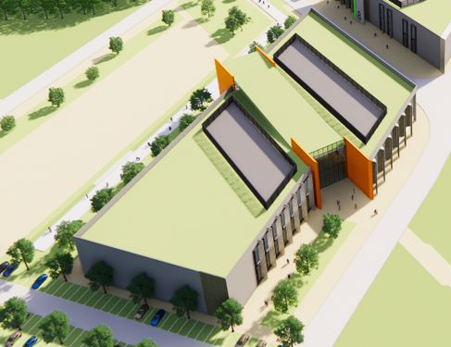
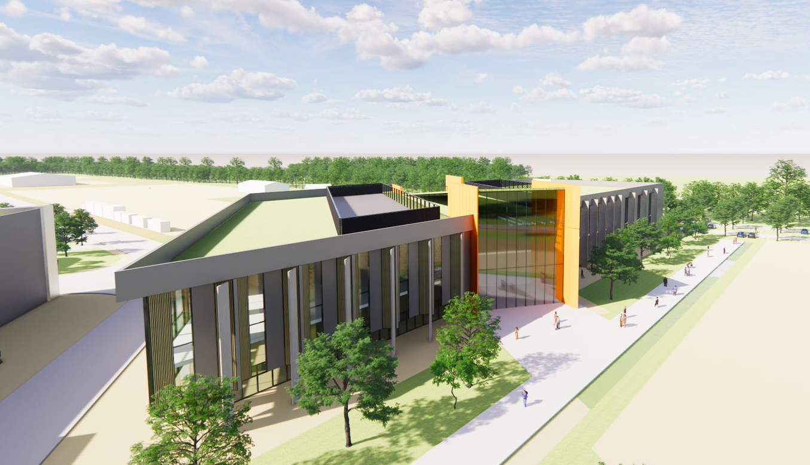

DISC at Westcott
DISC at Westcott
DISC at Westcott
DISC at Westcott
DISC at Westcott
DISC at Westcott
DISC at Westcott
DISC at Westcott
DISC at Westcott
DISC at Westcott
DISC at Westcott
DISC at Westcott
DISC at Westcott

Satellite Applications Catapult
  - Full Business Case | June 2021

Executive Summary

The UK is creating a national Launch and In-Orbit Services capability for the next generation of Low Earth Orbit satellites. Buckinghamshire and Westcott are in a strong position to take advantage of this high-impact opportunity, defined in their Local Industrial Strategy. A Disruptive Innovation for Space Centre (DISC) at Westcott will provide industry with a critical entry point to this rapidly expanding Space market, anchoring economic activity in the UK, and creating the means to develop and apply novel launch, propulsion, and satellite technologies.
The commercialisation of near-Earth Space is a massive growth opportunity for the UK and one that will demand we marshal our very best capabilities if we are to reap the benefits for our citizens and society in the face of stiff global competition.
Space is already a major part of our critical infrastructure, providing the tools that enables a modern society to function, like communications and transport, protecting our citizens, and providing the means to manage our environment including the pressing threat of climate change. Space also provides a massive opportunity for economic growth, much needed as we recover from the pain of the recent pandemic and other global pressures.
Stepping up to the opportunities and challenges that Space offers is not a trivial task. If we are to compete with the rest of the world it demands a great deal of effort to marshal our very best resources. DISC provides a transformational capability designed to unlock the full potential of the UK Space sector and meet these challenges.
DISC fulfils an immediate requirement for companies entering the UK Space sector, or existing companies developing new capabilities, who want to access specialist equipment and manufacturing facilities without the initial heavy cost of ownership. Instead, DISC allows users to rent access to cleanrooms, test chambers, assembly rigs and other specialised equipment on a needs basis, at commercial rates, until design concepts are proven and ready for production.
To complement this, we will integrate a Skills Academy into the high-tech DISC innovation environment. This approach will provide industry users’ with access to much-needed new talent thorough apprenticeship and training programmes, a critical requirement to grow the new Space secto.
In one stroke, DISC lowers the entry barrier to market and creates a level playing field for UK-based companies who want to develop new skills and create new products, applications or services for this exciting and fast-moving sector.
Our plan is to commission and lease a purpose-built facility, on a commercial basis, from the Westcott site landlord (Patrizia AG). Our request, and the purpose of this Business Case, is to secure £30m from the Bucks Growth Deal funding to equip and fitout this facility ready for DISC operations by September 2023.
During the delivery of the project the Catapult will form an Enterprise Alliance with industry to build the infrastructure and service environment that will ensure that DISC fulfils its objective to accelerate and shorten the duration between innovation and production readiness for commercialisation. The Enterprise Alliance will also work together to ensure the Skills Academy meets business needs whilst also attracting the right talent to Westcott and the space secto.
Strategically, investing in DISC at Westcott links directly to the goals for the UK National, Arc and and BLEP Local Industrial Strategies and to UK launch ambition.
Strategically DISC has been designed to address the most pressing barriers to the UK Space sector’s growth and development. These issues relate to providing industry with open access to infrastructure and equipment that is prohibitively expensive for Commercial R&D on individual projects, offering a service environment that fills capability and skills gaps during supply-chain development, creating a portal for Industry to access new markets and collaborations, and accelerating Inward Investment to support growth.
The DISC at Westcott is intended as a forerunner of a network of DISC facilities across the UK, themed to support different aspects of the Space sector’s supply-chain needs. These will range from upstream requirements for launch, propulsion systems, satellite and payload manufacture, to downstream applications, products and services for Transport, Energy, Maritime, Agritech and Health etc. Each DISC will act as a catalyst for growth, helping industry to take bold steps in the design, development and commercialisation of new products and services.
Westcott DISC represents the scale and ambition of what is required nationally. Each DISC will attract new industry to a region and create the conditions to provide further innovation capability and
large-scale production capacity. The DISC project is being proposed at a time when international focus is on the commercialisation of low earth orbit space. DISC makees this opportunity immediately accessible. Adoption of this project will position Westcott at the heart of the UK Space sector agenda for growth to £40bn pa by 2030 as outlined within the BLEP strategic economic plan and Local Industrial Strategy. DISC also complements the Prime Minister’s ambition in his inaugural speech: “let’s get going now on our own position navigation and timing satellite and earth observation systems - UK assets orbiting in space with all the long-term strategic and commercial benefits for this country.”
Economically: Our impact analysis predicts companies utilising DISC at Westcott will create 753 direct jobs and deliver a £387m NPV and 4.38:1 BCR. The stimulus provided in terms of lowering the entry barrier to market will contribute significantly to demand for production capacity in the region.
The DISC environment enables businesses to develop design concepts from early prototypes through to first production models. During this process companies can collaborate with other organisations to establish market ready product and service offerings. As these mature the business operation also grows, which in turn creates opportunities for new jobs and skills development supported by the co-located Skills Academy.
This Business Case captures only the direct benefit on jobs that DISC has the capacity to generate. However, as companies leave the facility to scale for full production, there is a far greater secondary impact on job creation associated with the commercialisation of market ready products and services. Its this potential that attracts different Industry players to the DISC environment (e.g. AVS, ASTRA, Lockheed Martin, Rolls Royce, Northrop Grumman, Jacobs, Airborne Engineering, New Space Systems, Nano Avionics, MagDrive, Benchmark Systems etc). DISC will also support wider collaborations with companies on-site such as Nammo and OneWeb.
Commercially: DISC is a proven concept and already heavily oversubscribed at Harwell.
This case is served by two fundamental commercial principles.
The first principle of DISC therefore, is to provide an innovation environment that is affordable, flexible, additive and open to all.
This first principle is realised through the provision of much needed infrastructure and skills. Companies developing new designs require support to minimise business exposure to risk. The most pressing issues that companies face are affordable R&D manufacturing environments that enable them to scale and have access to skills and training.
The second principle of DISC therefore, is to provide a highly collaborative busness environment for companies to form supply-chains that open up new markets.
The second principle is delivered through the provision of a multi-layered service environment that enables companies to collaborate in forming supply-chains, accessing end users, and opening routes to market. In the UK, we have an excellent reputation for innovation but a poor track-record for commercialisation. Companies developing new designs and prototypes need a platform to close-out capability gaps in delivering a market ready solution, without loosing control of IP. Far to often many entrepreneurs or start-up companies fail to open sufficient routes to market and chose instead to sell their IP to overseas competitors for a fast return.
Delivering on these two commercial principles will set DISC apart from any other National asset, attracting Industry from overseas as well as domestically to work in the region. The commercial value of this environment is recognised within the financial case, but the return on this investment captured by the economic case provides a compelling justification for this investment | Financially: The NPV, deadweight and LAG calculations show the DISC project is financially viable. DISC is expected to break even in its’ 4th year of operation in 2026/27.
Demand established by the DISC at Harwell underpins the financial assumptions for this Business Case and focuses on industry with interest in locating operations to Westcott. Following quickly on from the development of the Innovation Centre at Westcott, this £30m investment demonstrates that Buckinghamshire can mobilise to deliver the necessary infrastructure, which achieves the required financial impact.
The financial case for DISC is elevated by the proposed DISC service environment designed by Industry to close a significant failing in the market. Revenues generated from the suite of optional business services that DISC provides its Users further strengthens the financial model and accelerates the return on investment, shortening breakeven by several year.
Management: From design to occupancy the project will be managed and delivered by the Catapult Enterprise Alliance partner-based team, who will work in collaboration with the site landlord, Patrizia AG.
The Satellite Appllications Catapult has an experienced team with a proven track record of completing Government Grant funded projects to time, performance and cost. Over the past five years we have delivered DISC at Harwell (oversubscibed) and the Westcott Innovation Centre (newly opened and home to OneWeb).
This team will have sole responsibility for the procurement of DISC equipment and will work in patnership with the site landlord Patrizia who will fund the design and build of the DISC factility. The Catapult will then install and commission the Grant funded equipment into this facility ready for commercial operations.
The Catapult recognises that the long-term commercial success of the DISC operation requires a wider partner-based approach. To this end, we will assemble a team with the pedigree for delivering large-scale commercial operations. During the construction phase of the project, the SA Catapult and its partners will form an Enterprise Alliance to secure commercial investment and develop the Service and Gateway environments for DISC operation. The Enterprise Alliance will be commercially funded, providing private match funding to the project, and will assume full responsibility for the DISC operations once it opens for business. The Enterprise Alliance construct is described within Section 5 Management Case of this document.

https://www.gov.uk/guidance/how-we-are-promoting-and-regulating-spaceflight-from-the-uk

